
ARDON®SPRINGI
FUNCTIONAL UNDERPANTS

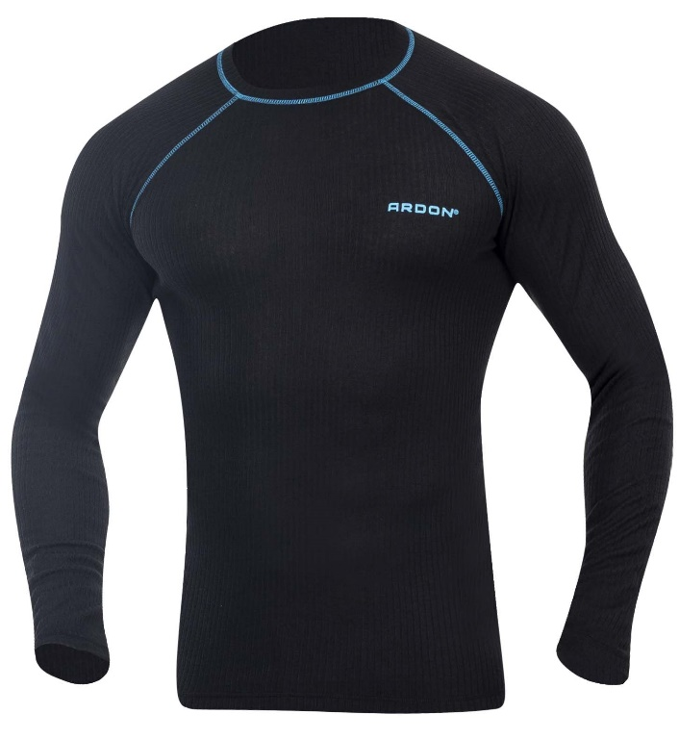
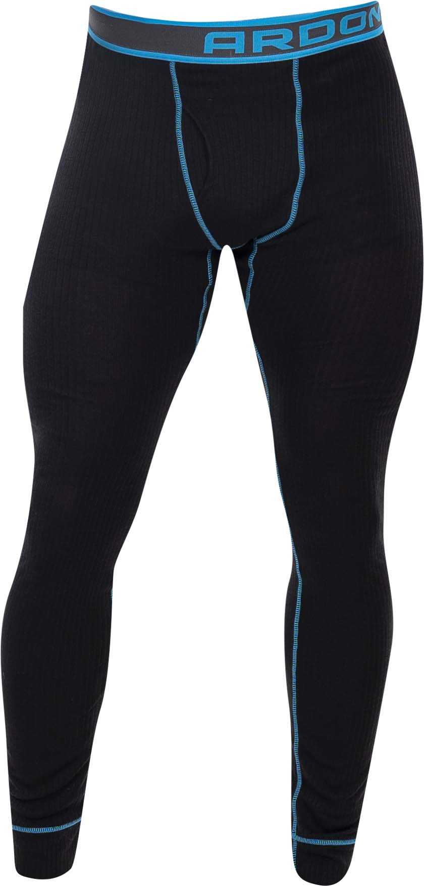
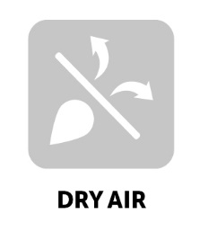

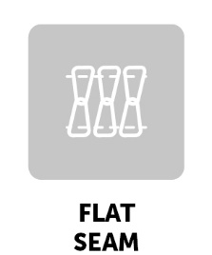
TECHNICAL DATA SHEET
ARDON®SPRINGI
FUNCTIONAL UNDERPANTS
ARTICLE H6155 (t-shirt, long sleeves)
H6156 (underpants)
MATERIAL 100 % polyester
GRAMMAGE 200 g/m²
SIZE S-3XL

DESCRIPTION
Quick-drying functional long-sleeve undershirt and underpants made of a pleasant, breathable and soft material that combines functionality, elasticity and moisture control, and keeps your body dry even during demanding exercise. Wearing comfort is guaranteed by fl at seams.
This personal protective equipment is in conformity with the requirements of the following harmonised standard:
TECHNICAL DATA SHEET

ČSN EN ISO 13688:2013 – Protective clothing - General requirements
PPE of simple design against the minimum risks that may be quickly
and safety recognised by the user.

The self-certification was carried out on the basis of the technical documentation of the product and practical tests of ergonomics propreties of the product by Ardon Safety s.r.o. on 20 January 2021.

NUMBER OF PIECES IN CARTON pcs
CARTON WEIGHT kg
CARTON SIZE m³
UNIT PACKAGING pc

The service life depends on the rate of use and the rate of wear in the given
conditions. Inapropriate storage conditions, improper maintenance and care
reduce the service life. The warranty period is 24 months. Under no circumstances
should the warranty period be confused with the service lefe of the product. With
Intensive use, the service life may be shorter than the warranty provided.

The product does not contain any substances in concentrations that are known or
suspected to have an adverse effect on the user´s hygiene of health. However, skin
irritation is not impossible for sensitive people, in which case do not continue to
use the garment. Avoid the fire and sources of intense heat. No accessories or
replacement pants are intended for these garments. If the garment is not in use, it
Is recommended to store it in a dry and well-ventilated area away from direct
Sunlight. Transport best in original packaging, protect from moisture and extreme
temperatures. Dispose ecologically after use.

TECHNICAL DATA SHEET
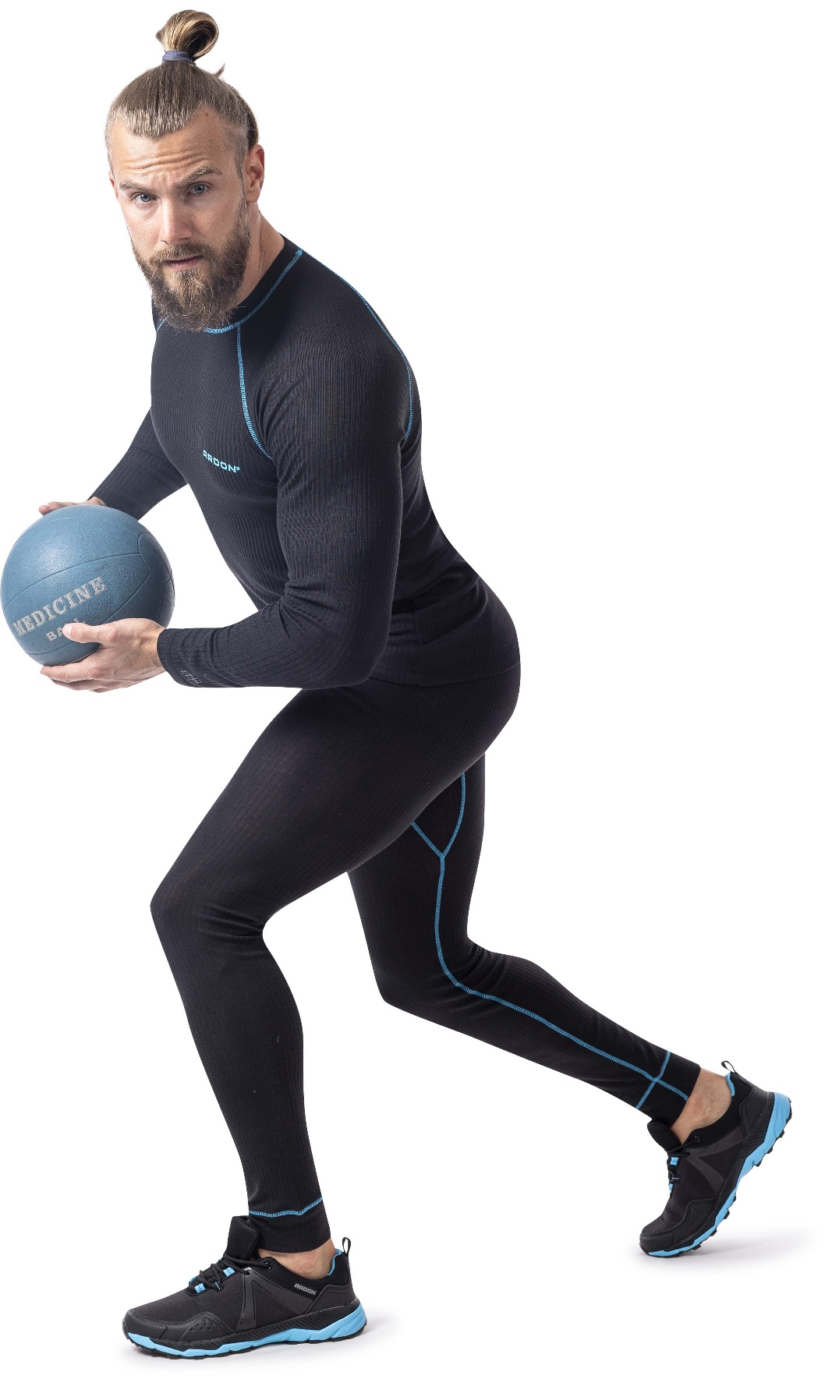
TECHNICAL DATA SHEET

