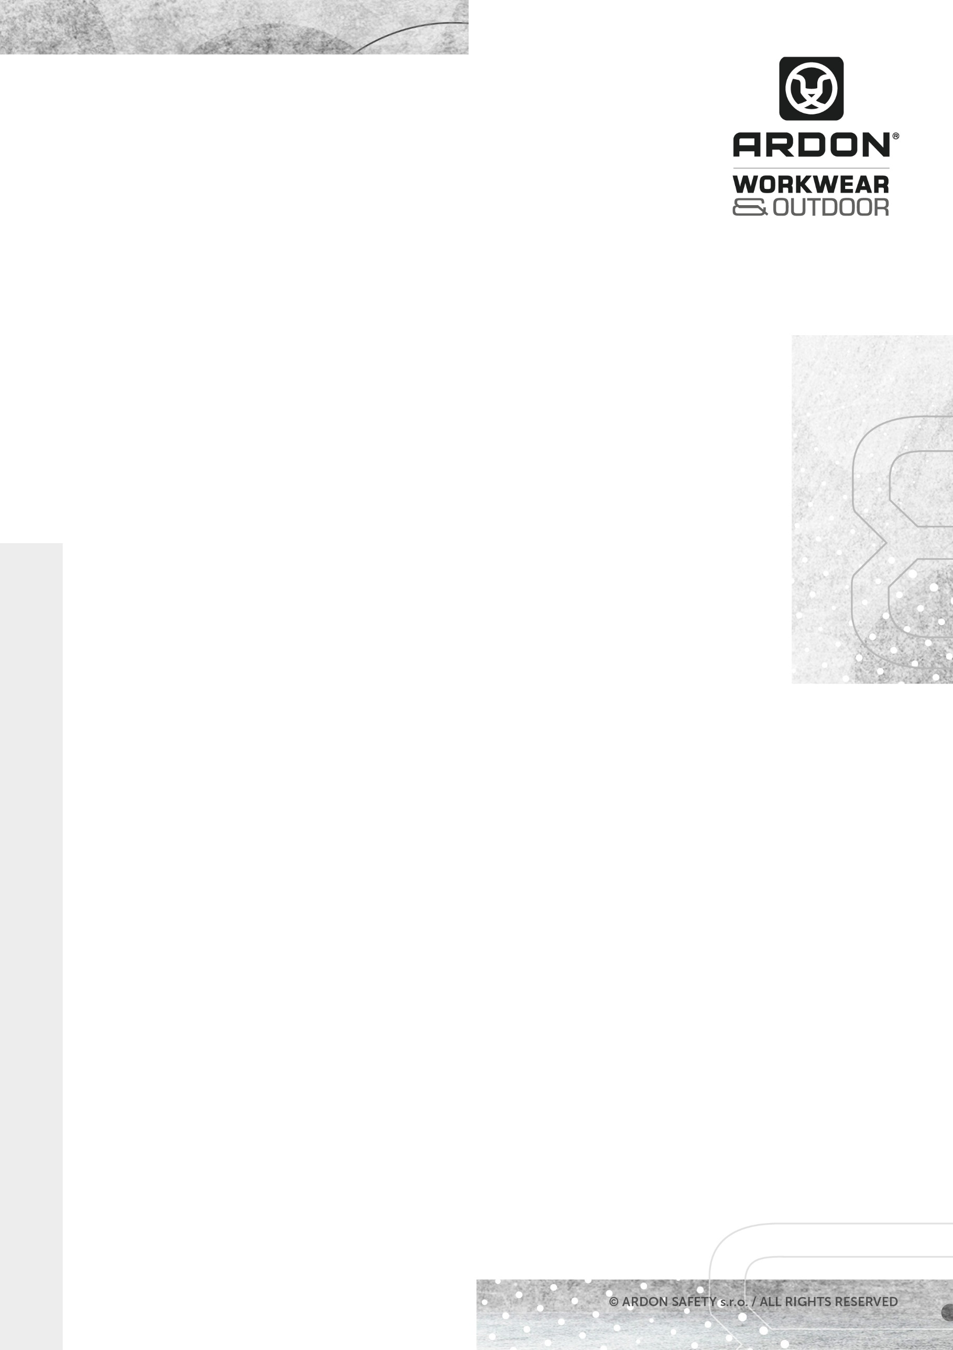
ARDON®ZIDYN
POLO SHIRT

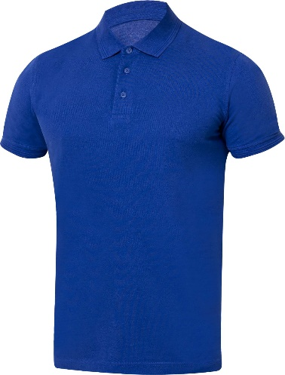
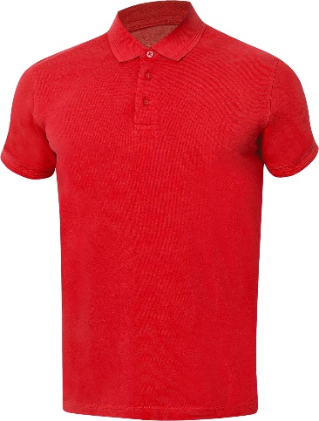
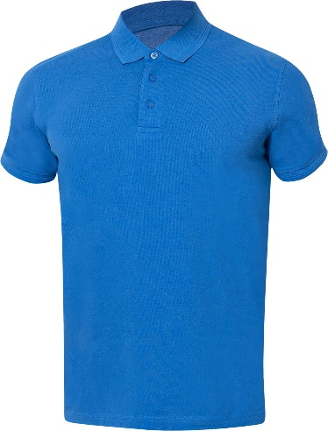

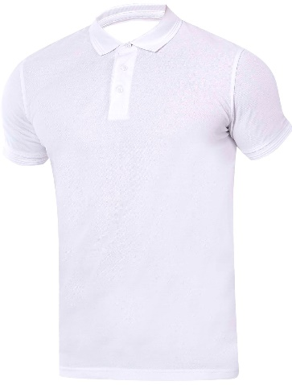
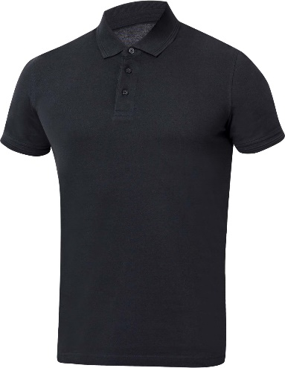
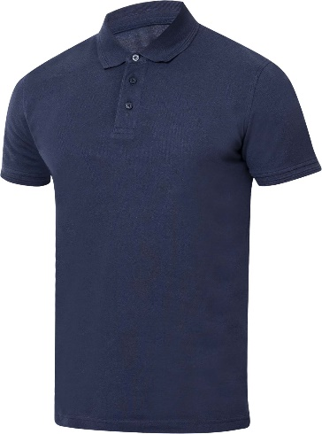
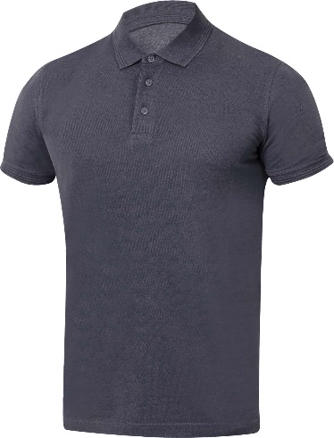
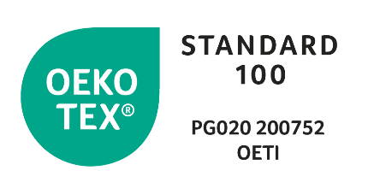
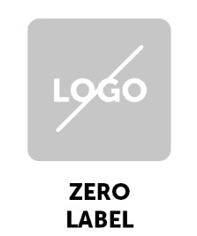
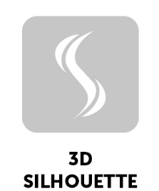

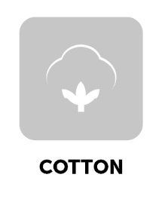

TECHNICAL DATA SHEET
ARDON®ZIDYN
POLO SHIRT

ARTICLE H13286 (red)
H13285 (blue)
H13284 (medium blue royal)
H13283 (dark blue)
H13282 (dark gray)
H13280 (black)
H13281 (white)
MATERIAL 100 % cotton piké
GRAMMAGE 200 g/m²
SIZE S-5XL

DESCRIPTION
A men's polo shirt made of pre-washed cotton, which is more resistant to colour bleeding, and especially eliminates shrinkage after washing. The polo shirt made of pique cotton features a collar with a design element also found on the sleeve hem. The button placket is reinforced with a decorative patch, the bottom piece is extended and has side slits. The modern cut of the sleeves emphasizes the shape of the shoulders. The fabric is treated with a silicone layer that softens the surface, adds shine and extends the life of the product. The polo shirt has only a small size label sewn into the neckline and a label with material and maintenance information. The monochrome ZERO LABEL design makes the polo shirt the ideal product for merchandise and creative designs.

This personal protective equipment is in conformity with the requirements of the following harmonised standard:
TECHNICAL DATA SHEET

ČSN EN ISO 13688:2013 – Protective clothing - General requirements
PPE of simple design against the minimum risks that may be quickly
and safety recognised by the user.

The self-certification was carried out on the basis of the technical documentation of the product and practical tests of ergonomics propreties of the product by Ardon Safety s.r.o. on 20 January 2021.

The ZIDYN Collection meets health requirements and is OEKO-TEX®Standard 100 certified, PG020 certificate 200752 OETI.

NUMBER OF PIECES IN CARTON 20 pcs
CARTON WEIGHT 6,5 kg
CARTON SIZE 0,031 m³
UNIT PACKAGING 1 pc

The service life depends on the rate of use and the rate of wear in the given
conditions. Inapropriate storage conditions, improper maintenance and care
reduce the service life. The warranty period is 24 months. Under no circumstances
should the warranty period be confused with the service lefe of the product. With
Intensive use, the service life may be shorter than the warranty provided.

The product does not contain any substances in concentrations that are known or
suspected to have an adverse effect on the user´s hygiene of health. However, skin
irritation is not impossible for sensitive people, in which case do not continue to
use the garment. Avoid the fire and sources of intense heat. No accessories or
replacement pants are intended for these garments. If the garment is not in use, it
Is recommended to store it in a dry and well-ventilated area away from direct
Sunlight. Transport best in original packaging, protect from moisture and extreme
temperatures. Dispose ecologically after use.

TECHNICAL DATA SHEET
TECHNICAL DATA SHEET

